Economics of Land Use and Land Use Changes within Water Catchments Ecosystem in Kenya

Chapter One

Introduction
  - Background
“Many ecosystem services have not been easy to detect until they stop to flow and as such not been properly captured in economic systems, in fact the impact services loss have been referred as ‘externalities’ . In addition, even when a value can be credibly estimated and will be referred as a cost or benefit accruing to society at large, rather than to the individuals or companies responsible, so there is little, if any motivation for the various entities actors to care for the natural resources or ecosystem in question. Furthermore, the net value of converting an ecosystem are artificially skewed by subsidies, tax breaks, and other government sponsored incentives for the conversion. The Failure of the current markets to appreciate a significant contribution by environment are the prevalent influences of the huge environmental losses of the past half century documented by the Millennium Ecosystem Assessment . However, when these externalities become a significant cost burden to society, such as restoring degraded river systems, it becomes a priority to understand and value ecosystem services and to integrate them into economic frameworks”. Despite early indications of their enormous economic value, ecosystems continue to be lost. This then calls for generation of the necessary data through application of global approaches at local scale and be able make available any time it is required especially in business and government entities to support decision making. The process of valuing the broadest possible range of ecosystem services will generate public and private investment in the long-term supply of these services and will cushion humans against any likely collapse or transformation of a natural system.
Additionally, in a world where there is an increasing demand for goods and services from ecosystems, it will be critical to study how our traditional policy instruments like taxes or quantity regulation can cope with ecosystems’ potential paradigm shifts . Information on the level and distribution of resources scarcity would be demonstrated by valuation on limited ecosystem resources as defined through economics of natural capital . The valuation of ecosystem services and biodiversity is a reflection of what the society will be willing to trade off to conserve these natural resources. The cost of resource scarcity and degradation presented policy making process and associated with land use would be explicitly demonstrated through economic valuation of ecosystem services and biodiversity. Otherwise, when the costs are not imputed, society will be misguided through poor policy guideline that would result to improper allocation of the already scarce resources. Ecosystem and biodiversity economics would be viewed as part of our natural capital and thus benefits or services from ecosystem will then be the dividend/profit humanity receives from the from the capital. There is global response focused on reversing the unsustainable use and degradation of ecosystem and biodiversity though the efforts are compounded on scarce information on both changes, status, drivers of change and the impact of management retort .
Society has to make prudent choices to maintain certain threshold of the natural capital and biodiversity to ensure continued flow of ecosystem services that support functionality and human well-being analogous to choices made on certain business portfolio to manage risky returns. Worth noting the impact of ecosystem and biodiversity change affect humanity. Nonetheless, though patchy, some information exist that is either highly procedural and unsuitable for policy makers or not readily available . In fact, instrumental data on ecosystem services and ecological economics have so far been generated globally though with myriads uncertainties and criticism.
The discourse on ecological economics can be traced to more than three decades with the nature benefits appearing in academic prose late 70’s . The theory and practice of current focus on monetary ecosystem services valuation plus payment schemes has so far fascinated political debate though with some arguing ecosystem valuation being aimed at commoditizing or privatizing nature. The concept is also believed to have reproduce the neoclassical economics paradigm and the market logic believed to tackle environmental issues. The inkling of benefits of nature has been discussed in the academic literature for a very long time with some arguing that nature benefit discussion has been there as long when human existed . Conversely, ecological economics was established with view of linking ecosystem ecology and resource economics while espousing the theoretical academic work and indigenous knowledge together other related science . Ecosystem services on the other hand have an unequivocal been part of the research agenda of ecological economics from the beginning .
The ecological economics finding have therefore enhanced the understanding to some extend on how the natural environment matter to human society globally. In some parts of the world natural environment forms part of the capital asset equally important along with other assets that include physical, social, human and intellectual capital. However, there has never been change on how humans exploit the natural environment. Otherwise, if no stringent measure taken to reverse the trend, then universe is will be losing the very critical natural capital it dearly need support human welfare. Degradation of natural resources has still continued and has become more apparent that nature degradation is costly, both to local owners and to society in general, over multiple time and space scales . The 20th and 21st century recorded the highest level of degradation with some the critical ecosystem almost disappearing as a result unsustainable exploitation appetite .
Notwithstanding, ecological economic has not so far penetrated local framework especially in policy development and in decision making processes. While the assumption would be the government are aware of economic value of the ecosystem, it has not been clear why it is not being cascaded to all cadre of government.
Valuation should not be seen as a panacea, but rather as a tool to help recalibrate the faulty economic compass that has led us to decisions that are prejudicial to both current well-being and that of future generations. The invisibility of biodiversity values has often encouraged inefficient use or even destruction of the natural capital that is the foundation of our economies .

Statement of the problem
Increased degradation, deforestation, overexploitation of natural resources, habitat loss, encroachment into riparian and the introduction of exotic species has negatively impacted biodiversity and ecosystem services delivery . Though still challenging to predict the impact of current and future human exploitation, what is clear is the livelihoods of poor and marginal societies, that have a high propensity of experiencing significant impact of the dwindling environmental resources they depend for their sustenance . Notably, the scarcity of resources and improper waste disposal has dominated the 21st century that currently concerns the globe . Apparently, many ecosystem are nearing tipping points due to overexploitation and degradation as a result may not provide services to human welfare though uncertainty exist on what level of disturbance different ecosystems can withstand before it is unable to bounce back. Besides, significant number of ecosystem have surpassed this thresholds, there now exist ‘dead zone’ in certain marine and fresh water ecosystems that are no longer able to sustain aquatic species, with similar scenario experienced in terrestrial ecosystem that have transitioned into deserts. Globally, biodiversity studies have indicated the risk of extinction resulting from continued reduction of species and habitat fragmentation. Risk of extinction is connected with constant or intensified habitat disturbance, pollution, invasive alien species, over exploitation, population pressure, push for economic growth and impact of climate change . Additionally, natural capital loss and degradation is also coupled with failure of business and policy to fully account for ecosystem services and biodiversity . The other issue is either the policy has failed to acknowledge this problem, or is incapable to identify solutions to the dwindling ecosystem benefits and the concept of sustainable utilization . The incapability of ecosystem to provide the necessary benefits to humanity is evidently a consequence of society actions . Though ecosystem values are not visible in economic growth, natural resources are fundamental in livelihoods improvement and national growth. In fact, natural resources constitute an impetus for economic production and essential conditions for the health and quality of life globally (KNBS, 2008). However, there is limited data and understanding on how biodiversity contributes to stability and functionality of ecosystem that would latter translate to services to humanity. For instance, riparian zones contribute to water quality improvement and reduction on dregs . Though, apportioning of values to biodiversity attributes not a forthright especially the stated preference, and the focus being on identifiable ecosystem benefit that may not reflect species biodiversity contribution per se , there will still be need to enquire into the paradox in order to address some of the uncertainty often associated societal preference. For example forest ecosystem plays a critical role in water flow and quality but the relationship between water regulation and purification to biodiversity is poorly understood though there are strong relationship of soil and vegetation to water flow and storage . Ecosystem services and biodiversity, ecological functions, ecosystem services, resilience and human wellbeing are poorly understood for many . Scanty knowledge on how ecosystem service are affected by disturbances and changes of biophysical factors and how they are related with the level of biological diversity in a given ecosystem is the grave missing link. Though information gaps will always exist, it will be critical to unwrap the uncertainty on how the ecosystem works. Worth to note, humanity fails to appreciate the accrued from ecosystem since benefit from unknowingly. The other issue is on failure to account potential benefits as well as disservice that should be looked into consistent with ecosystem accounting framework .
The study therefore intends to first account for the value of every ecosystem benefit provided by water catchment ecosystems in Kenya and secondly endeavor to establish some of threshold beyond which irreversible harm can be reached. The latter will develop a mathematical model to synthesize and quantify ecosystem service as well as understand dynamic, non-linear, spatially explicit trade-offs as part of the larger social-ecological systems. Using the mathematical relationships then able to calculate shadow prices for natural resources, elasticity of substitution, and total factor productivity among services based on pragmatic evidence. Albeit, the complexity in the connections between ecosystem processes and functions and human wellbeing, a pluralistic and precautionary approach will be undertaken in assessing these connections and valuation of services. The study will establish key indicators that will convey information on the consequences of loss of biodiversity through an acceptable process. The approach for development of model will be robust and homogenous to capture the non-linear and multi-scale relationships between the ecosystem and the services they provide. The indicators should later be convertible into economic metric units in order to realize the full value of ecosystem and biodiversity. Nonetheless, the development of the model should ensure wide consultation of the stakeholders to assure relevancy. These models can incorporate and aid accounting and assessment exercises and link directly with the policy process at multiple time and space scales. Model even with different ecological and social-economic scenario should be able to compute future ecosystem services changes .

Justification of the study
Worth noting, the term economics is about making choices and every resolution is heralded by a consideration of values amongst other available alternatives. Ecosystem provide essential services that are critical for economic growth and human welfare. However, the current market has captured a few component of the system which can be priced and assimilated in private business transactions either as services or merchandises. This set-up is limited in making since it will not be a reflection of the ecological values in any decision making process discourse . Additionally, failure will arise from a society that is not able to comprehensively compute the value of most services provided by nature. In this regards, total ecosystem valuation will unwrap the complexities that are often associated with socio-ecological relationship be able to present it in metric units that would easily be expressed in decision making processes . It will be necessary when any decision in relation economics is made, it ensures inclusivity in all the components that genuinely contribute to economy however marginal they may be . Similarly, total valuation of ecosystem and biodiversity is likely to establish the missing and imperfect markets that often overlook the immense contribution of natural capital and as a result account natural resource through methods such as Net Present Value (NPV) method. Even without any subsequent valuation, the very process of listing all the services derived from an ecosystem can help ensure their recognition in public policy. This makes the analysis of ecological systems more transparent and can help inform decision makers of the relative merits of different options. Nonetheless, valuation is often useful, because many decisions involve trade-offs between ranges of things that affect human wellbeing differently. That notwithstanding, the society has no option whichever way it would want to present the ecosystem values either explicitly or otherwise though with uncertainty will still be regarded as valuation.
Valuation whether done explicit or implicit will be a very powerful tool for self-reflection on our natural environment and will inform society on the trends and consequences of the choices and demeanour it makes. It equally acknowledges the costs of conservation and can promote more equitable, effective and efficient conservation practices. Some school of thoughts argue valuation of ecosystem services and natural capital is unnecessary and there should be not ‘price tagging’ for nature. On the contrary, the misconception may not be true since value does not necessarily mean or equal ‘price’ since nature valuation concept reflects both marketed and non-market goods and services. Otherwise the whole ecosystem worthiness visibility would be clearly demonstrated through valuation . Whichever side one bases the argument pricing nature or not it simply implies that ecosystem has values that would need to explicitly demonstrated for society to make rational decisions
There is need for decision-making process develop a different approach than has been traditionally used when such regime shifts were rare events . Value-based research could generate some insight on resource use and non-use values that would be necessary for managers and policy makers of the current era. Economic indicators could not be the only condition in decision making but would rather complement other indicators such as the Indicators for Sustainable Development Goals (SDGs). Often it is the only credible basis for opposing the special interest spin on values, and the only way to discourage wasteful environmental investments or ones that are not in the public interest
This study will be useful towards contributing threshold beyond which irreversible harm will be caused. This will be able to establish optimum level of use, extraction, distribution and income generation. Similarly, it will also provide a means to justify and set priorities for programs, policies, or actions that protect or restore ecosystems and their services as reported in earlier studies. Furthermore, it will provide and avenue for resources managers to deal with the effects of market failures, by measuring their costs to society in terms of benefits lost thus estimate of appropriate costs to be imposed against society, individuals, or institutions those responsible.
Additionally, the study will perform cost-benefit analysis that will provide some insight on how to examine the net economic benefits that a society accrue from investment on protection of water catchment and wetland ecosystem in Kenya. The analysis will take into consideration the likely inter temporal nature of the returns, thus rationally information on the distribution and timing of benefits and costs that could help resolve issues of fairness and equity among those affected by a conservation program .
Overall total economic concept will play an important role in environmental policy review, payment of ecosystem services schemes, development of watershed ecosystem standard analysis and decision-making. The latter will promote rational thinking as opposed to intuition that aggregates economics consideration focuses on the outcome rather the process and empirical studies behavior which does support economic theories of preference. The concept is likely to promote a universal notion on environment and reverse the narrative on ownership and property as well as propel changes on how humans appreciate nature i.e. changes in both individual and collective preference. That notwithstanding, individual positive change of preference in this case will be apparent. It will be necessary to understand the link between economic indicators with other categories of ecosystem stability indicators such as biological diversity and abundance. These indicators will guide in providing appropriate measures to attain sustainability and minimise its impact on environment and society.

Hypothesis
H_{oa}: Watershed and catchment ecosystem has more economic values than has been presented by a number of studies
H_{ab:} Ecological stability and biological diversity will mean more flow of ecosystem services and goods thus economic stability and sustainability
H_{ac}: The current level of extraction of natural resources impacts negatively on the flow of ecosystem services in watersheds in Kenya
H_{ad}: Failure to account for ecosystem services and biodiversity in policy and national economic growth has more cost than benefit.
Hae: encroachment into in critical water courses has a negative economic consequence to the flow of ecosystem goods and services

Objectives
Main Objective
To determine total economic values of watersheds and catchment ecosystems in relation to current land use and land use changes in Kenya
Specific Objectives
- To determine total economic values of ecosystem services provided by watershed and catchment areas in Kenya.
- To determine the economics of exploitation to flows of provisioning ecosystem services within the watershed and catchment areas in Kenya
- To determine the economics of biological diversity and ecosystem functionality in relation to the influence on flow of ecosystem goods and services
- To determine economic consequences of failure to include ecosystem values in policy reviews and private investments.
- To determine the economic consequence of encroachment into critical water courses within the watershed and catchment ecosystem in Kenya

Research questions
- What is the total economic value of watershed and catchment ecosystems in Kenya?
- What are the economic consequences of current level of extraction on continued flow of ecosystem goods and services?
- What is the economic relationship between biological diversity and ecosystem functionality with scale of flow of goods and services that ecosystem provides?
- What would be economic consequence for failure to incorporate natural capital in natural policy and economic growth discourse?
- What is the economic consequence of not protecting critical courses within water catchment areas in Kenya?

Study scope
The study will be conducted in four of the water towers and the surrounding wetlands in Kenya and this will include Nyambene and Aberdares water towers falling within the Tana catchment zone while Elgeyo and Namanga water towers fall within the rift valley drainage basin. The study will be hybrid undertaking that is an ecological and socio-economic survey. The socio-economic is aimed at answering the land use and land use change economics in relation to water tower ecosystem and the surrounding wetland ecosystems while ecological survey will majorly endeavour to answer biological indicators and their relationship with the ecosystem services flow. The output would then be used develop a robust mathematical models using a multi-variant analysis tool that would preferably be used to determine the watershed ecosystem value in future.
1.7.1 Total Economic Valuation (TEV)
Total economic valuation will employ a six phase approach with phase one being identification of the study scope, location, spatial scale and the study focus; phase two establishment of geographic and ecological boundaries; phase three identification and categorization of ecosystem services; phase four determining the role of ecosystem services and economic valuation; phase five identification of degradation patterns and pressure; and finally phase six conducting cost-benefit analysis on a ‘action’ scenario vis-à-vis a ‘business as usual’ scenario.
The study will endeavour holistically capture ecosystem services based on The Economics of Ecosystem and Biodiversity (TEEB) categorization that is as provisioning services, regulatory services, Cultural services and habitat services. Valuation will be computed through preference-based approach that models human behaviour and satisfaction on the assumption that values arise from the subjective preferences of individuals. This perspective will also assume that ecosystem values are commensurate with the monetary terms, among themselves as well as with human-made and financial resources. Subsequently, monetary measures will then offer a way of establishing the trade-offs involved in alternative uses of ecosystems. Finally, the survey will perform cost-benefit analysis to determine consequences of ‘business as usual’ scenario against taking a sustainable management action. In this manner, action may be evaluated on whether it provides net economic benefits to society or otherwise. Alternatively, management approaches or programs may be compared to determine which provides the greatest net economic benefits.
The study will survey individual’s decisions, where they will reveal their preferences for commodities that are infinitely divisible. The values will be represented in monetary units and the existing prices that should reflect marginal valuations. The study will employ indirect or direct valuation methods since most of environmental goods and services cannot always be bought and sold on markets and there are not always market prices.
    - Linking biological diversity, ecosystem functionality with services flow
Biological measures and indicators are already available, though developed for different purpose not economic valuation that will convey the necessary information about ecosystem health and its functioning . However, available measures and indicators can only capture a few species and ecosystem mostly relevant to provisioning services and thus likely to miss out the role of biodiversity and ecosystems in supporting the full range of benefits, as well as their resilience into the future. The study in this regard will establish a ray biological indicators and measures in the study area that will not only be able to convey message of the consequences of biodiversity loss, but also accepted across wide range of stakeholders that reflect the aspects of biodiversity involved and the service that is of interest, capture the often non-linear and multi-scale relationships between ecosystems and the benefits that they provide, and be convertible into economic terms. The intention of this to convey information on biological processes, functioning that finally leads to delivery of services that supports human welfare and both local and national economy. This then implies a lot goes in the ‘system’ before the final product ‘benefit’ is provided which calls for establishing the status and structure of ecosystem and whether it is able to deliver the requisite benefit in quantities and quality that will meet the rising human demands.
    - Development of Integrated mathematical model
The study intents to develop a mathematical model that takes into consideration varied ecosystem services and attributes in order to integrate multiple incommensurable values. It will employ Multi-criteria analysis approach for ecological and socio-economic data that will make it possible to integrate multiple values after each of them has been assigned a relative weight/ regression coefficient. The output of the tool will rank of preferences that serve as a basis for taking decisions among different alternatives, but without the need to convert all values to a single unit. This is aimed developing a robust tool that will accounts for complexity in ecosystem biological diversity and functionality with the flow of services.
To address the likely biases and wide acceptance the development of the model will identify and engage software and computer program developers, the beneficiaries of ecosystem services, those who are providing the services, those involved in or affected by the use, and the actors involved at different levels of decision-making.

Theoretical and conceptual framework
Worth to note provision of ecosystem to society is product of a functioning ecosystem that undergoes nature ignited process . Ecosystem and biodiversity is comprised of biophysical structure such as vegetation cover that undergoes natural processes such net primary productivity. The biophysical and process would then makes a ‘system’ work i.e. function for example nutrient cycling, soil formation, water cycling etc.. The product of a functioning ‘system’ then provides services such amelioration of climate, protection from floods, fodder for livestock some among others. The delivery of service will be dependent on ecological structure and processes. For example, water and nutrient cycling process is needed for provision of fresh and clean water while primary production will be fundamental for enhanced game service. The services provided will beneficial to society through various ways for example, clean water used for domestic use, game provide nutrition, income from tourism and slow flow of water movement will as a function will reduce flood risk thus protect human lives and property. In one way or the other, institution and human judgement plays a key role in either maintaining the cycle or otherwise through actions they undertake on the use of services provided (Figure 1).
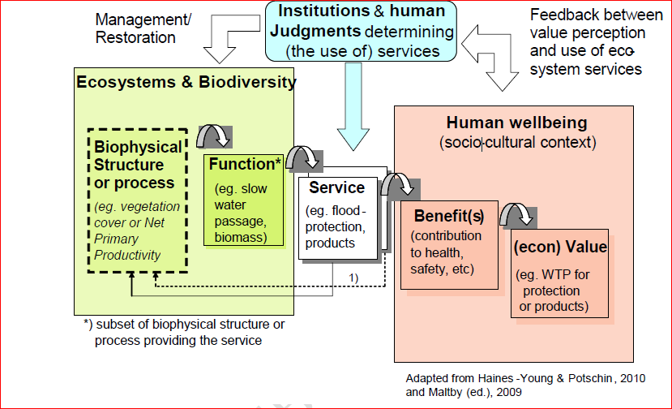
Figure 1. The Cascade of ecosystem structure, process, function to service than to benefits and values. (Source: Adopted from )
That notwithstanding, value of environment includes use and non-use values . The use value are categorized into three groups that is direct, indirect and optional values while the non-use values are grouped into bequest and an existence or ‘passive’ use values (. All the values equated to services have been grouped into four major categories that is according Millennium Ecosystem Assessment (MEA), 2005 i.e. provisioning, regulatory, cultural and supporting services, while The Economics of Ecosystem Biodiversity (TEEB), 2010 adopted the first three categories and included habitat service instead of supporting service. According to TEEB, support services is an ecosystem function for it to be able deliver other services.
Worth noting, services provided by ecosystem is what benefits society and that is what makes it worth. Therefore, for an ecosystem service to be worth the should an interaction and feedbacks among natural, human, built and social capital. (Figure 2) Depicts an interaction between these components for example ecosystem provisioning service to be worth there must be human capital, built and social capital that is fuel wood collection require human to collect (Human capital), while a group women collecting fuel wood in forest would be categorized as fuel wood group (social capital). Regulatory service though not so much appreciated, will require the other three capitals to be worth its services. For example, flood control will need people (Human capital) and property (Built capital) to be protection from flooding. Cultural service on the other hand will need people to appreciate the aesthetic value, road and means of transport for people move to the scenic sight and to some extend hotels (built capital) for refreshment and sleeping at night. Even ‘existence’ and other ‘non-use values’ require people (human capital) and their cultures (social and built capital) to appreciate.
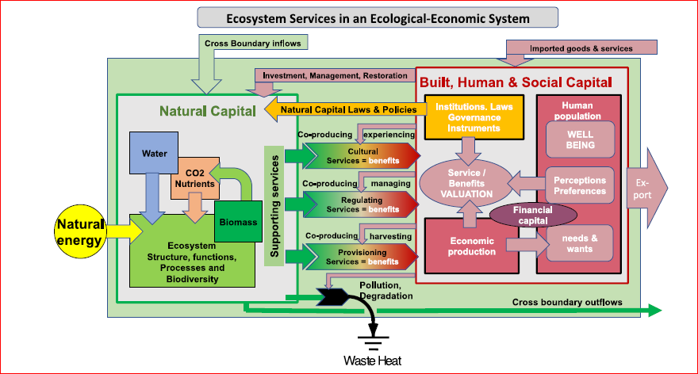
Figure 2. Complex interfaces between natural, human, social and built capital(Source: Designed by Robert Costanza, )

Chapter Two

Literature Review

Theoretical principles
2.2. Previous work done related to the study

Chapter Three

Materials and Methods

3.0 Introduction
The chapter details the frameworks and approaches that the study will employ in an attempt to answer the questions of total economic value, the linkage of ecosystem biological and structural attributes with the services they provide and development of assessment tool for local and national valuation of water catch and wetland ecosystem, and discusses how they are connected. It is segmented into study design/ approach, study area, sampling design and sample size determination.

Study design
The study will apply a robust mixed approach aimed at accommodating quantitative and qualitative assessment on magnitude, frequency and influence of human use natural capital. To generate some background information on economics of ecosystem and biodiversity, the study will apply exploratory design. The approach will define terms, clarify existing concepts, determine what methodology and establish priority domains. Casual design will at some instances be applied in examining a link of impact with extend of exploitation to ecosystem resources. Impacts and extend of exploitation will treated as dependent and independent variables respectively. To monitor the trend of ecology in the ecosystem, the study with apply panel or longitudinal design to track changes if any over time and establish the direction and magnitude of casual relationships. For non-use benefits cohort design will be applied to generate some insight on the influence of the current rate of human utilization to the benefits’ quantity and quality. Both secondary and field survey data will be used to make inference and recommendations. Additionally, where necessary the study will perform some experiments both in-situ and ex-situ. The experiment should be able to identify cause effect relationship ecological variables and distinguish placebo effects from treatment effect.
Total economic valuation will adopt a six-phase approach adopted from Economics of Land Degradation(ELD) Initiative in development of the ELD user guide expanded from United Nation Convention to Combat Desertification (UNCCD) and the ELD 2013 & 2015 report. These frameworks and approaches will be rooted to an economic perspective and allow stakeholders to consider alternative options for action. These options for action are based on alternative livelihood options, which include economic sectors of land-based activities. The valuation will include both market and non-market services, as well as public and private benefits. The study will decompose ecosystem services into independent component that will be valued separately without duplicating the value of a single service across categories. The total economic value of the ecosystem is then the sum of the values of the identified individual services. The six phase framework (Table 1.) will include initiation, analysis of geographical characteristics of the target ecosystem, identification and categorization of ecosystem services, establishing the role of ecosystem services to the livelihoods of community in each land cover local and overall development the study zone and latter estimate the total economic value. Similarly, the study will map out the ecosystem degradation patterns, drivers and the existing pressure. Finally, conduct a cost benefit analysis in order to present cost and benefit and ‘action’ vis-à-vis ‘business as usual. Economic values estimates will be used to develop a statistical model to guide the latter valuation. The study will ensure a wide stakeholder consultation is undertaken on identification and categorization of benefits to address the challenges that may presented by the services and goods provided by the ecosystem under investigation.
Table 1. The six phase approach (the concept is adopted from ELD guide 2015)
Phases | Description | Method for data collection
Initiation | - Outline the scope/ extend; location; focus; spacial scale (community level, national, regional or global level study);  - Identification of geographical/ecosystem boundaries; land cover categories  - Identification of partner institution that may support the research  - Preparation of background materials/papers on the socio-economic and environmental context of the assessment through desktop review. This will ensure that the cultural, biophysical, and socio-economic situation needs and drivers are understood  - Basic approach and rationale of the study is explained and strategic issues discussed | - The information can be generated through, reconnaissance visits, structured stakeholder mapping/ consultation/ engagement; literature review;
Ecosystem Geographic characteristic | - Establishment of the target ecosystem (geographic and ecological boundaries)  - This stage involves an assessment of quantity, spatial distribution and ecological characteristics of the land cover including land cover change over time  - After mapping of the study area using appropriate GIS programs, different land cover categories are then identified and grouped into standard agro-ecological zones  - The land cover category include forestland, cropland, settlement, grassland, wetland, bare land etc. | - The information will be generated through wide engagement and consultations of the ecosystem stakeholders, ground trothing  - General science literature/ desktop research on the target ecosystem’s physical geography, ecology, soil, landscape etc. will be used to define and map land cover and agro-ecological zones  - At global scale desktop research or through analysis of remotely sensed satellite data such as Landsat  - At local scale secondary GIS information can be supplemented by participatory GIS data gathered through ground-truth
Categorization of benefits along the four classes of ecosystem services as provided by TEEB 2010 | - This involve identification and analysis of ecosystem benefit stocks and flows  - Aligning the benefits to four ecosystem services framework i.e. Provisioning, regulating, cultural, supporting services | - Wide stakeholder engagement and consultation  - Generate information of ecosystem economics data from case studies  - Secondary literature on ecology and ecosystem benefit  - Site visits and market research
Establishment of the role of the target ecosystem on livelihood and then valuation | - Involves identification of how the ecosystem support the livelihood of the community living within and beyond and the overall influence on economic development area adjacent to the study area  - This is then followed by estimation of the total economic value of each of the ecosystem service  - Estimate the benefits of action or the cost of inaction | - Wide consultation and engagement of the stakeholders  - Generate information of ecosystem economics data from case studies  - Primary data collection through surveys  - Multi-criteria analysis in identification of ecosystem services  - Use ecosystem services valuation techniques where necessary i.e. market prices, replacement cost, dose-response estimation, avoided damage cost, mitigation costs and opportunity cost and Revealed preference and Stated preference  - Extrapolation of case studies for global comparison (benefit transfer)
Mapping resource use, resource change over time and pressures | - Involve identification of ecosystem resource use, change & drivers of change over time, degradation pattern, the available sustainable use options, pressure on resources and the drivers to sustainability  - Mapping the spatial distribution of ecosystem resource use, pressure pattern for establishment of global scenarios  - The information is necessary for development of alternative scenario for cost benefit analysis | - Stakeholder consultation and engagement  - Use secondary literature on the target ecosystem soil science, ecology, agriculture, and physical geography in order to establish the type of land degradation, patterns and pressure  - Use of GIS to establish ecosystem degradation, pattern and pressure  - Landsat imagery and Homogeneous Image Classification Units (HICU) approach will be applied for land cover classification (forest, grassland, cropland, settlement, bare land, water body, wetland etc.)  - Unit Stream Power based Erosion Deposition Model (USPED) for estimating soil erosion and deposition
Comparing costs and benefit of action against status quo | - This involves analysis of cost against benefits of ‘action’ scenario in comparison with ‘business-as-usual’ scenario  - Action based scenario include ecosystem management strategies undertaken to either mitigate or remove degradation pressure e.g. controlling the number livestock into the forest in relation to the carrying capacity while ‘business as usual’ scenario is either letting nature take its course or continued exploitation of resource until it is completely depleted e.g. allowing more livestock into the forest without considering the carrying capacity  - Analysis will also involve mapping the viability of ecosystem resource management strategy in given site in economic perspective i.e. identification of site specific management actions that are economically desirable  - Economic viability Cost-benefit analysis purposely meant to compare the cost of adopting a sustainable ecosystem management strategy/practice against the benefit derived from it  - Action success estimated by three key economic indicators ( net present value, internal rate of return and benefit to cost ratio) and as such determine whether the action is financially worth undertaking | - Wide consultation and engagement of stakeholders  - Participatory establishment of action scenario as well as status quo scenario, choice of discounting rate, computation of economic viability indicators on cost –benefit analysis  - Use of GIS to mapping of resources  - Participatory estimation of shadow interest rate  - Ecosystem benefit analysis Tools such as Toolkit for Ecosystem Service Site-based Assessment (TESSA); Corporate Ecosystem Service Review (ESR) Assessment and Research Infrastructure for Ecosystem Services (ARIES); Integrated Valuation of Ecosystem Services and Trade-off (InVEST); Multi-scale Integrated Models of Ecosystem Services (MIMES); Natura 2000

Total Economic Valuation Framework
The framework will adopt preference-based approaches, where the ecosystem services equated use and non-use values will be decomposed into independent component for easier computation and summation (Figure 3). Use values are economic utilities attached to a resource with direct benefit while non-use values are economic utilities that has no direct benefit such as existence values, bequest values and steward values. Use values can further be categorized as direct use and indirect use values. Direct use values comprise in most cases of provisioning services such as fuel wood, fruits, or fish while indirect use values are those entities not consumed directly but which indirectly support directly consumed goods such as flood control or storm protection. Non-use value on the other hand, are the economic worth of ecosystem that is not associated with consumption as aforementioned they include existence value, bequest value, and stewardship value. The non-use value is the economic worth apportioned to the subject ecosystem for its existence, ability to support other ecosystem service and preserved for future generation that is a perspective of eco-centrism.
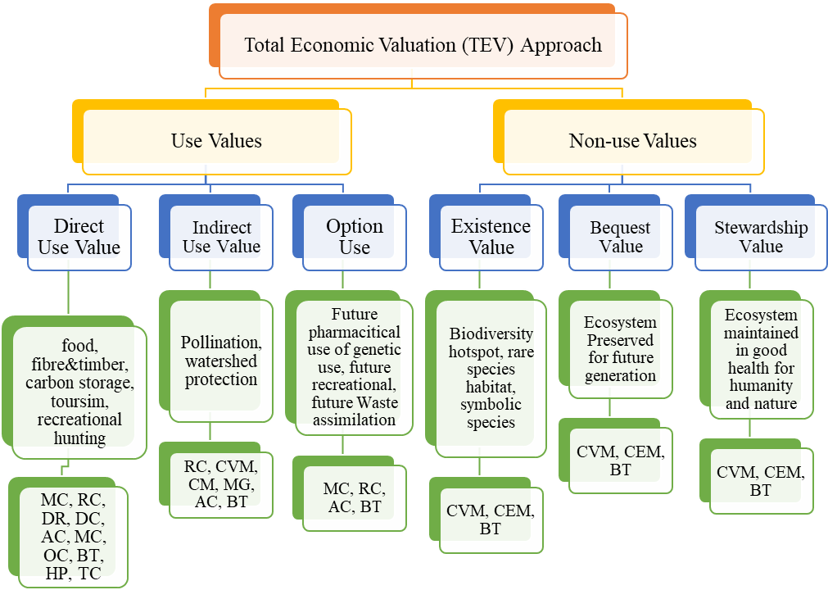
Figure 3. Framework for total valuation of ecosystem system and respective techniques (Adopted from

Direct market valuation techniques include the market price (the monetary value of goods and services that can be bought and sold in commercial markets) and their production function (an estimate of the contribution of a certain ecosystem service to the production of other marketable good) . Without direct market prices for environmental goods such as biodiversity, their value can be inferred using consumer preferences . Revealed preference techniques that is indirect valuation approaches based on observed consumer behaviour and include hedonic pricing, travel cost and replacement cost methods for analysing individuals’ actual choices. The hedonic pricing method serves to calculate the value of environmental goods such as landscape, air quality, and noise. This method evaluates the implicit price that individuals are willing to pay for the relevant environmental characteristics based on house prices, the time, and money spent on recreational trips or other expenses . The replacement cost method, on the other hand, quantifies the cost of replacing or restoring an ecosystem service . While revealed preference techniques are useful only for use values, stated preference techniques can serve to assess the total ecosystem valuation (i.e., use and non-use values) . Stated preference techniques derive from respondents’ answers to questions about how much they would be willing to pay to maintain/improve the quality of the environment. The contingent valuation method; or after presenting them with choices between goods and expenses, the choice modelling approach
The study will survey individual’s decisions, where they will reveal their preferences for commodities that are infinitely divisible. The values will be represented in monetary units and the existing prices that should reflect marginal valuations. The study will employ indirect or direct valuation methods since most of environmental goods and services cannot always be bought and sold on markets and there are not always market prices. Direct method will be used by asking people of the benefits acquired since the delineation of protected areas in Kenya. similarly indirect method will be employed and this will rely on observations of how changes in “environment” affect individual behaviour . Travel cost and contingence costing (willingness to pay approach) on recreational service and other non-market products.

Linkage of ecosystem & biodiversity functionality and services provision
The study aims at establishing indicators of a functioning ecosystem in order to track its performance; monitor the consequences of alternative policies; and area of further study. The indicators will be able simplify and quantify facts in order to easily transform data into information necessary to the respective consumers in making their decision . Using the existing measures and indicators, analysis will be conducted to identify the most appropriate for the purposes of assessing the economic consequences of biodiversity and ecosystem change. In the same milieu, good measures and indicator with of course high level of precision and robustness should be able to accommodate wider scale ecosystem assessment. They should also be reliable and have a record of applicability in other similar or related studies. The latter, should be able to establish the relationship of benefits accrued from ecosystem and biodiversity. Nonetheless, the indicators will have an appropriate temporal and geographical coverage, and ideally spatially explicit as emphasized by Balmford . On how the ecosystem benefit flow, continuity and use, the research will make use of the data generated from form socio-economic survey on valuation. The economic data will be extrapolated for the value of the respective ecosystem and biodiversity attributes. The study will assess the respective attributes in terms of diversity indices, quantity, and condition build on two levels of diversity that is species and ecosystem. Assessment will also include indicators such as land cover, vegetation structure, soil, nutrient related and the pressure exerted to the ecosystem. However, to establish the link of the attributes and benefits, ecosystem services will be grouped according to TEEB categorization to include provisioning, regulatory, cultural and habitat services and valuation as aforementioned will employ both direct market pricing, stated and revealed preference techniques.

Integrated Model Development
The study utilize the biophysical and remote-sensing data generated through field survey to develop an integrated model with aim of espousing measures of stock quantity and degradation drivers, with measures of diversity and condition in order to ensure a full accounting of the value of biodiversity and ecosystems for future prognosis. Multi-criteria analysis will be employed to ensure incorporation multiple values and attributes that will generate a relative weight/ regression coefficient. The output of the tool will rank of preferences that serve as a basis for taking decisions among different alternatives, but without the need to convert all values to a single unit. This is aimed developing a robust tool that will accounts for complexity in ecosystem biological diversity and functionality with the flow of services

Socio-economic survey
Socio-economic surveys will be conducted through administration of questionnaires developed in three folds; household, key informants, and focused group discussion. The data collection will be based on livelihood framework with identification of assets endowment structured on social, financial, physical, human and natural capital. The data from the both household survey will be used to understand benefits accrued from the neighbouring ecosystem and estimate economic values of the benefits the community draw from ecosystem. The key informant survey will be used to collection information on market prices, perceptual values on degradation and level of forest resource exploitation. Focused group discussion will on the other hand be used to collect data on ecosystem services stock flows and quantities, non-market prices, products extracted from the forest and land ownership
Similarly, the study will also conduct market survey in the neighbouring trading centres to collate information retail prices on forest products. This will give product and value chain plus trends of demand and supply. Where data products are not unclear or distorted then establish the proxy’s prices.
- Estimation of forest biomass
Ground-based and remote-sensing measurement will be utilized to estimate ecosystem carbon stocks using allometric relationships. Estimate of emission will be based on biome averages as a starting point. Ground base carbon mapping will apply non-destructive approach where tree parameters are record to avoid cutting trees for physical measurement. The tree measurement will be converted to carbon estimate using regression models. This was done on two major tree carbon pools i.e. stem and root biomass of any tree with DBH≥ 5 cm. permanent plots will established mapping of both aboveground and below ground biomass will based on IPCC 2006 framework .

Study area and population

3.2.1 Description of the study area
The study will be conducted in four of the water towers in Kenya, two of which are gazetted that is Nyambene in Meru County & Aberdares in Nyeri County the two yet to be gazetted is Elgeyo in Elgeyo- Marakwet County and Namanga Hill in Kajiado County. A water towers are generally mountainous regions or highland areas that acts as a receptacle of precipitation that discharges water into aquifers underneath and/or gradually releases to the rivers, lakes and springs emanating from it as surface water . In most cases water towers include gazetted state forest with a buffer of stretching from the forest boundary to between 5 and 10 Km depending the status the ecosystem. The Water Towers cover six of Kenya’s main drainage basins; these are the North Rift, South Rift, Rift Valley Bottom, Western, Central Highlands, Eastern and Coast. These drainage basins are exhibited by inland lakes to include Lake Turkana, Natron, Magadi, Elementaita, Naivasha, Bogoria, Baringo, Victoria and the Indian Ocean. Apart from the five known water towers Mount Kenya, the Aberdare range, the Mau Forest Complex, Mount Elgon and the Cherangani Hills, Kenya has gazetted an addition thirteen since the inception of KWTA. This include Chulyu Hills, Huri Hills, Kirisia Hills, Loita Hills, Marmanet Forest, Mathews Range, Mount Kipipiri, Mount Kulal, Mount Marsabit, Mount Njiru, Ndotos, Nyambene Hills, and Shimba Hills. However, Kenya has other water towers and water sheds which require deliberate effort to protect and conserve, including their catchment ecosystems. In addition, 70 more water towers including Elgeyo hill, Namanga hill have been identified by Kenya Water Towers Agency and are in the process of publication on national gazette .

3.2.1.1. Nyambene Water Towers (Study site I)
Nyambene Hills Water Tower is one of the gazetted water towers in Kenya located in Meru County. The Water tower has been identified as a key water tower due to its numerous resources including provision of water resources for the communities around Meru, Igembe and Maua areas. The Water Tower is located in northern side of Meru County and traverses Igembe South, Igembe Central, Tigania East and Tigania Central Constituencies. It borders Meru Central on the West side, Tharaka on the South, Isiolo on the North East and Tana River and Mwingi on the South Eastern side. It lies between latitudes 0º 17’N and 0º 8’N, and longitudes 37º 48E and 37 º 52’ E (Figure 4).
The state forest was published in Kenyan gazette of 1969 under the then Forest Department currently Kenya Forest Service, covering approximately 6,878.40Ha including the Nyayo Tea zone belt that stretches approximately 120Ha. Nyambene forest is predominantly an indigenous forest punctuated by small proportions of plantation forest totaling approximately 67Ha. The plantation forest is composed of Eucalyptus species, Grevillea and Vitex Kiniensis species. Vitex Kiniensis is an indigenous species that performs very well in this area and has been adopted for plantation establishment in small proportions. The forest is subdivided into 4 blocks that include Nyambene, Kirimandingiri, Keiga, and Thuuri, The four blocks have been further subdivided into 8 beats for the purposes of management to include Kangeta, Mbaranga, Michi-mikuru, Keiga, Thuuri, Kiegoi, Athi and Kirimandingiri. Each of the 8 beats is managed by at least 2 forest rangers. Nyambene block is the largest block. Thuuri Forest block is the furthest block located approximately 50 km from Nyambene forest station.
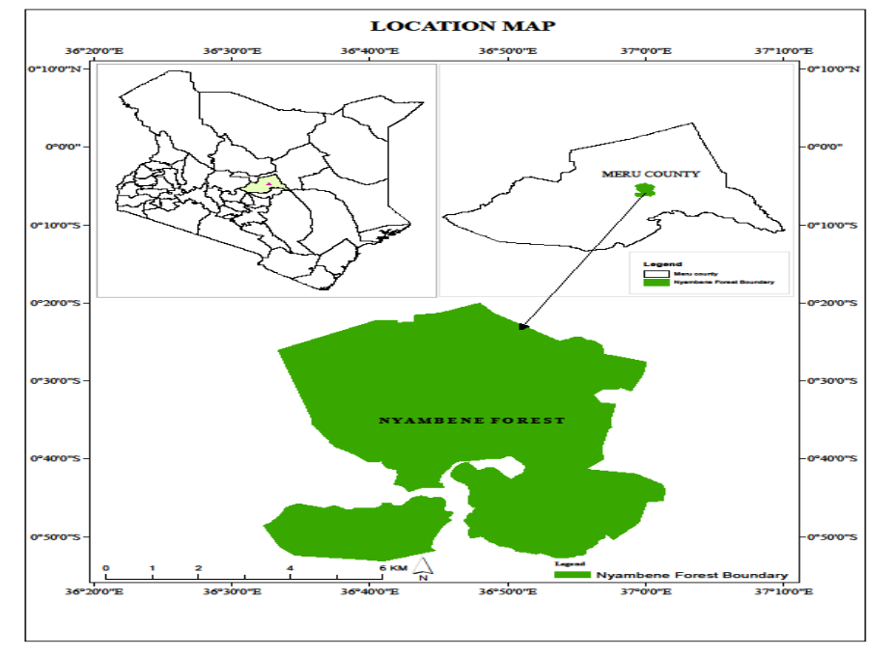
Figure 4 Map Nyambene Hill Water (Study Area One)

3.2.1.2 Aberdare Water Towers (Study area II)
The Aberdare Range is located in central Kenya, on the eastern edge of the Rift Valley. The forest belt of the Aberdare Range comprises a number of forest reserves, including the Aberdare, Kikuyu escarpment, Kijabe Hill, Kipipiri and Nyamweru, as well as some forest areas in the Aberdare National Park. The forests cover over 250,000 ha that forms part of the upper catchments of Tana River, Kenya’s largest river as well as Athi, Ewaso Nyiro(North) and Malewa rivers . They are also the main catchments for the Sasumua and Ndakaini dams, which provide most of the drinking water to Nairobi. The forests are characterized by a high diversity of vegetation types, because of the wide altitudinal range (from 1,800 to 3,600 metres) and the climatic differences between the slopes. In addition, the Aberdare Range offers spectacular scenery for tourism. The Aberdares is highly favored by its altitude and rainfall, hence it’s rich diversity.
Due the vastness of the water tower, the study will concentrate at Sasumua, Lake Ol Bolosat and Malewa River catchments which reflects the geographical scope of the entire area. These three sub-catchments are in Nyandarua County (Figure 5). These sub-catchments fall under Upper Highlands (UH) and Upper Midlands (UM) agro-ecological zones with altitude and rainfall of between 2,000 - 4,001 meters and 1,400-2,200 mm respectively. The study area is characterised by two rainy seasons; from April to May, and October to November. According to 2009 Census, Nyandarua County had a population of 596,268 with population growth rate of 2.4 % annually. This population was projected to be at 722,498 persons in the year 2017 (Nyadarua CIDP 2013-2017).
Sasumua (36.58° and 36.68° east and 0.65° and 0.78° south) provides 15-20% of Nairobi’s water supply with a reservoir and a treatment plant situated on the southern part of the catchment. Hydrological services draining the Sasumua reservoir have over the years been affected by land degradation that is caused by deforestation. This has over the years resulted in increased treatment costs. Lake Ol Bolosat, the only lake in former Central Kenya highlands, is an important bird area and source of water for Ewaso Nyiro North River which flows through Thomson falls. It also supplies water to a number of urban townships including Nyandarua. Population pressure, deforestation and resultant land use changes has seen its surface area shrink by 68%. Thomson Falls is a major tourist (resident and non-resident) destination. River Malewa drains to Lake Naivasha, a wetland of international importance, with rich biodiversity
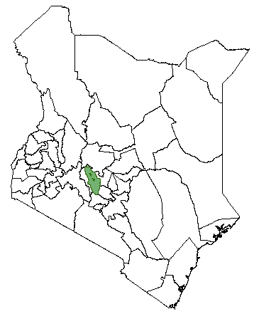 | 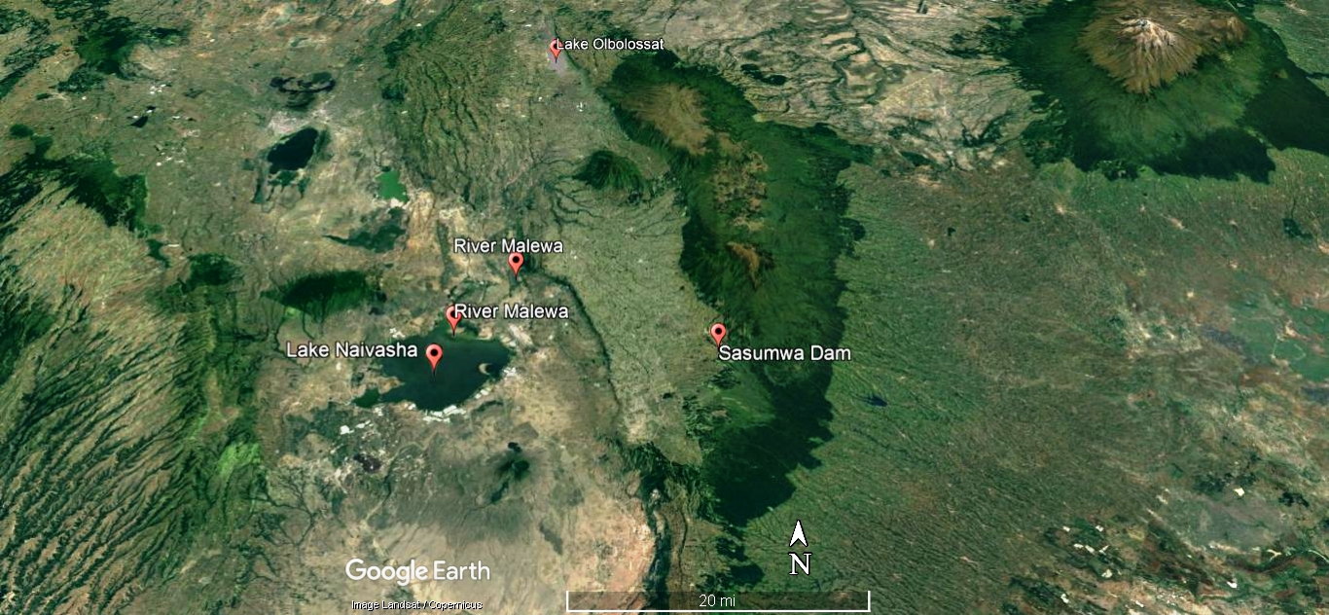
Aberdare –Range Forest |  | Counties Boundary
Figure 5 Map of Aberdare Water Tower
Elgeyo Hill Water Tower (Study site III)
Elgeyo Hill water Tower is located on the southern part of Cherangani Hills and traverses through Elgeyo-Marakwet and Uasin-Gishu Counties. The Water Tower has five major forest blocks that include Kaptagat (5663.6Ha), Sabor (4047 Ha), Kipkabus (6503.6 Ha), Penon (320 Ha) and Kessup. The larger section of the Water Tower is located within Keiyo South Sub-county. The water tower cuts across seventeen administrative locations i.e. Kitany, Nyaru, Kabiemit, Maoi, Tumeiyo, Kapkonyi, Metkei, Kaptarakwa, Mosop, Marichor, Mutei, Kapkwamul, Soy, Kibarkoy, and Chepsigor. The Kaptagat forest block for instance was proclaimed as a state forest in 1932 and later declared as such through legal notice No. 174/64 of 1964. Elgeyo Water Tower forest cumulatively, is estimated at 38,000 Ha whereby the indigenous forest cover approximately 23,000 ha while exotic cover an approximately 15,000 ha.
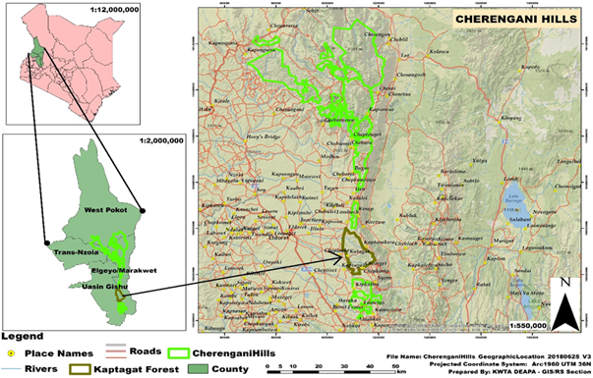
Figure 6 Map of Elgeyo Hill water encircled on the southern section of Cherangani ranges map
Namanga Hill Water Tower (Study Site IV)
Namanga Hills Forest Reserve is situated at latitude of S 02o 30’58.9 and E 36 o 47’13.6”It is located within Kajiado County north of the border town (Kenya and Tanzania) of Namanga in the southern part of Kajiado county of the Rift Valley Province in Kenya. . It extends 15-17km from north to south and 10km east to west covering an approximate area of 11,860.7 ha (Sanya 2002). The hill rises above the extensive plains of Amboseli basin to. The hill transverse Namanga, Oldonyo Orok and Mailwa locations. The largest part of the water consist of elevated cloud forest with and the highest peak is 2548m above sea level.

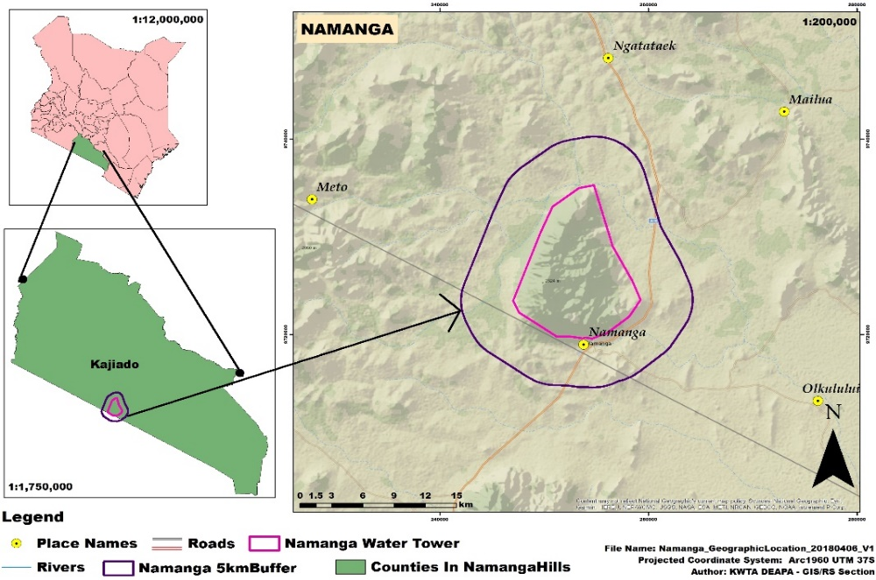
Figure 7 Satellite Map of Namanga map curved from Kajiado County
Namanga Hills Forest lies in the semi-arid and arid zones with only 8% of Kajiado County in which the forest is located being classified as having some potential for rain fed cropping mostly in the Athi-Kapiti Plains, close to Nairobi, and in the south of the county, along the Kilimanjaro foothills. The mean annual rainfall ranges from 300 to 800 mm and is bimodal, with short rains occurring from October to December while the long rains fall from March to May . The distribution of rainfall between the two seasons changes gradually from east to west across Kajiado County. In eastern Kajiado more rain falls during the "short rains" than during the "long rains". In western Kajiado the majority of rain falls during the long rains. The soils of the Namanga hills are mainly clay and sandy in texture. They are derived from volcanic ash and have moderate to high fertility. The soils are primarily of alkaline nature and are dark-brown red or grey clay. They are characterized into six sequences derived from volcanic tuff. On the hills, quartzite rocks of the Precambrian age stick out. The soils are shallow, stony with rock outcrops and lack acidic properties. Within the Namanga forest it is dominated by sandy clay loam, within the buffer is sandy loam .
Namanga water tower plays a key role in providing water for Namanga town and even beyond to part of Tanzania. There are three major rivers that originate from the Hill forest include Namanga River, Ekokidongoi, Engoboi River. These three rivers meet downsream near Amboseli National Park to form Lesigoyo River. The rivers have experienced significant change in the river flow volume and sometimes during extended prolonged drought some of the rivers end up drying up. This changes are attributed to encroachment of the forest that has led to destruction of the water catchment areas by clearing of the vegetation cover that help in retention of runoff water and recharge of underground water .

Sampling design
The study will apply mixed sampling strategy where it will cluster study zones based on geographical contiguity. Each study area will be treated as a distinct cluster. From each cluster depending on extend, will set at least two strata where for instance, state forest sustainable use zone will be treated as separate stratum while the buffer zone i.e. between 1-10 km from the forest boundary as another stratum. Each stratum will be sampled as an independent sub-population that individual elements will be randomly selected based on their distinct categories. However, quota sampling frame will be applied for socio-economic survey with the target population being segmented in exclusive sub-groups for instance state agency, non-state bodies as key informants, community groups as focused group while local community members will be sampled at household level. Personal judgement will be used to select subjects from each subgroup based on a specific proportion e.g. apiculture group, herders grouped based on activity they practice or participate. Sampling techniques will include, observation, interviews and administering of questionnaires. Ecological survey will concentrate on forest ecosystem the respective water courses employ stratified sampling where each study area will be segmented into at least two study clusters that is forest section as a cluster and the neighbouring wetland as a separate cluster and major river riparian as cluster as well. Within the forest cluster, four stratifications will be established converging at the central peak and depending on size of forest block at least three random sampling plots will be set of 100 by 100 meters distributed vertically to the forest boundary. The wetland ecosystem within the buffer zone will also be stratified into four clusters converging at the centre of the wetland and from each cluster at least two sampling plots will be set. The riparian ecosystem the buffer zone will on the hand be stratified into two clusters, one cluster being the river bank at least 50 meters from the highest water mark. The other cluster will be the water column for the case permanent rivers and the river floor for seasonal rivers.

Sample size determination
For ecological survey, each cluster will be partitioned into equal plots of 100 by 100 meter and with target confidence level of between 0.6 and 0.99, the study sample at least 30% of the number of plots of the entire study block. The socio-economic household survey will sample at least 30% of the households per administrative location within the buffer zone of the respective water tower.

Research instruments

Data processing and analysis
The study will apply Integrated Valuation of Ecosystem Services and Tradeoffs (InVEST) model to explicitly analyze the joint provision of services given an ecosystem and the many consequences and tradeoffs among services under alternative management is revealed. Monetary valuation will employ linear approach to be able to compute a per hectare value and ultimately multiply with number of hectares of the target area. However, due to dynamic ecological functions and values, the study will apply a robust non-linear approach that will incorporate variability, uncertainty, thresholds and regime shift. The model will ensure that distribution of benefits is considered as well as the relationship to poverty alleviation and general discussion on equity and justice.
Logistic regression analysis that utilises ordinary least square (OLS) estimation techniques will also be performed to determine whether any of the independent variables influenced the dependent variable. Since OLS assumes that variables are stationary, some unit root tests will first be carried out on the data to ensure that variables indeed exhibit stationary factors. Statistical analysis will then be carried out on quantitative data pertaining to variables chosen in the study to be explanatory or independent. Analysing the statistical significance of each of the variables will facilitate the drawing of inferences regarding the possible effect that a negative impact on some of the variables may have on the ecosystem values.
Diversity index from the respective study centres will be determined by Simpson and Tuomisto index . Correlation analysis will be carried out to examine relationships between some ecosystem attributes in respect to the level of exploitation across the study area. Advanced general linear model will be used to perform regression analysis and One-Way ANOVA test for significance test of the subject variables. Ultimately, Least Square mean will be used to make inference on the impact of human use to values generated from water catchment areas in Kenya. Significance difference was determined at P < 0.05 with 95% confidence level.

Data validation
Every data entered will be counter checked to detect recording errors and omissions. Instruments used will be calibrated before sample measurements to minimize instrumental errors. Marine domain parameter recording will be carried out in in simple triplicate to minimize random errors. Subsequently, the data recorded will be compared with the aquatic data available on government agencies data base to ensure that the study eliminates outlier and make corrections where necessary. Additionally, will engage at least two research assistants trained on coral reef biological survey that will concurrently collect data and their value averages will be compared with my own data and where necessary correct or get back to the field and re-do collection. Excel pivot table will be used to evaluate the data range where Q- Test will be used to verify the accuracy of the results. Later t-test will be used to test for significance and be able to identify and correct systematic errors. Analysis of central tendency will be carried out using mean, median and mode, range, standard deviation and variants. Analysis of Variance (ANOVA) will be used to calculate the measure of dispersion for all the statistical data obtained. Correlation and regression will be used to test for relationship of the obtained data.

Chapter Four

Work plan and Budget

Work plan/schedule

Table 2 Work plan/schedule
RESEARCH GOALS | YEAR 1 |  | YEAR 2 |  |  |  | YEAR 3 |  |  |  | YEAR 4
RESEARCH GOALS | 2018 |  | 2019 |  |  |  | 2020 |  |  |  | 2021
RESEARCH GOALS | S  O | N  D | J  F  M | A  M  J | J  A  S | O  N  D | J  F  M | A  M  J | J  A  S | O  N  D | J  F  M | A  M  J | J  A  S
Phase One: Development of the Project
Concept development
Literature Review: Environmental and Resource Economics
Proposal development
Proposal submission and approval
Literature Review
Phase Two: Data Collection
Permission: to KFS & the respective authorities
Familiarization field visit to the Four water towers
Meet with the respective stakeholders
Organize a meeting with the respective Community Groups within the water tower
Meeting with State and non-state Agencies
Designing Questionnaires for socio-economic survey
Mapping-out & Establishing sampling sites in the respective study areas
Conduct pilot study in Elgeyo Hill
Field work: Data collection/entry
Analysis
Data Presentation
Phase Three: Completion
Seminar and Conferences
Publish papers, compile questions and issues to explore in future research & assemble thesis
Draft thesis presentation
Final thesis write-up & submission for marking
Defence and correction
Final thesis

Budget

Table 3. The study budget
 | Year 1 | Year 2 | year 3 | Total
Stationary and printing | 50,000.00 | 30,000.00 | 30,000.00 | 110,000.00
Equipment hire & purchase | 150,000.00 | 150,000.00 | 150,000.00 | 450,000.00
Conference & seminars | 150,000.00 | 150,000.00 | 150,000.00 | 450,000.00
Samples purchase, sampling &lab analysis | 100,000.00 | 100,000.000 | 100,000.00 | 300,000.00
Travelling & accommodation | 300,000.00 | 300,000.00 | 300,000.00 | 900,000.00
Research assistance and samplers (allowances) | 100,000.00 | 100,000.00 | 100,000.00 | 300,000.00
International journal publication | 60,000.00 | 60,000.00 | 60,000.00 | 180,000.00
Documentation & publication costs | 60,000.00 | 60,000.00 | 60,000.00 | 180,000.00
Draft 1and 2: spiral bounded copies | 10,000.00 | 10,000.00 | 10,000.00 | 30,000.00
Draft 2: spiral bounded copies | 5,000.00 | 5,000.00 | 5,000.00 | 15,000.00
Final draft: six perfect bounded copies | 0.00 | 0.00 | 50,000.00 | 50,000.00
Sub-total | 885,000.00 | 865,000.00 | 915,000.00 | 2,965,000.00

REFERENCE

